CSA1505 - CLOUD COMPUTING AND BIG DATA ANALYTICS
Experiment-9

9. Create a simple cloud software application for Hospital information system for SIMATS Hospital using any Cloud Service Provider to demonstrate SaaS with fields of patient name, age, address, phone, email, Attender name, attender phone, doctor name, diseases, etc.

AIM:
To develop a simple Hospital Information System for SIMATS Hospital using Zoho Creator (Cloud Service Provider) to demonstrate the Software as a Service (SaaS) model. The application stores patient, attender, and doctor details, and manages patient registration through a cloud-based platform.
PROCEDURE:
- Log in to Zoho Creator.
- Create a new application named SIMATS Hospital Information System.
- Design a form with fields for patient name, age, gender, address, phone number, email, attender name, attender phone, doctor name, disease, appointment date, consultation fee, registration date, and patient status.
- Configure the required field types and drop-down values.
- Create a workflow to automatically record the registration date and set the patient status to Registered.
- Save and publish the application.
- Enter sample patient details and verify that the information is stored correctly.
INPUT:

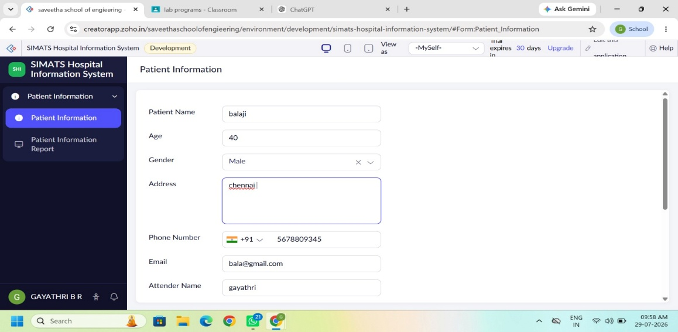
OUTPUT:

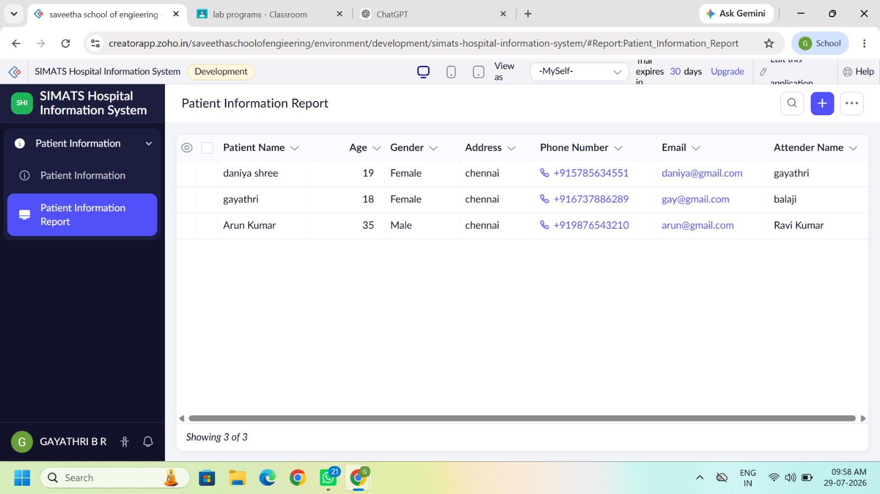
DESIGN:
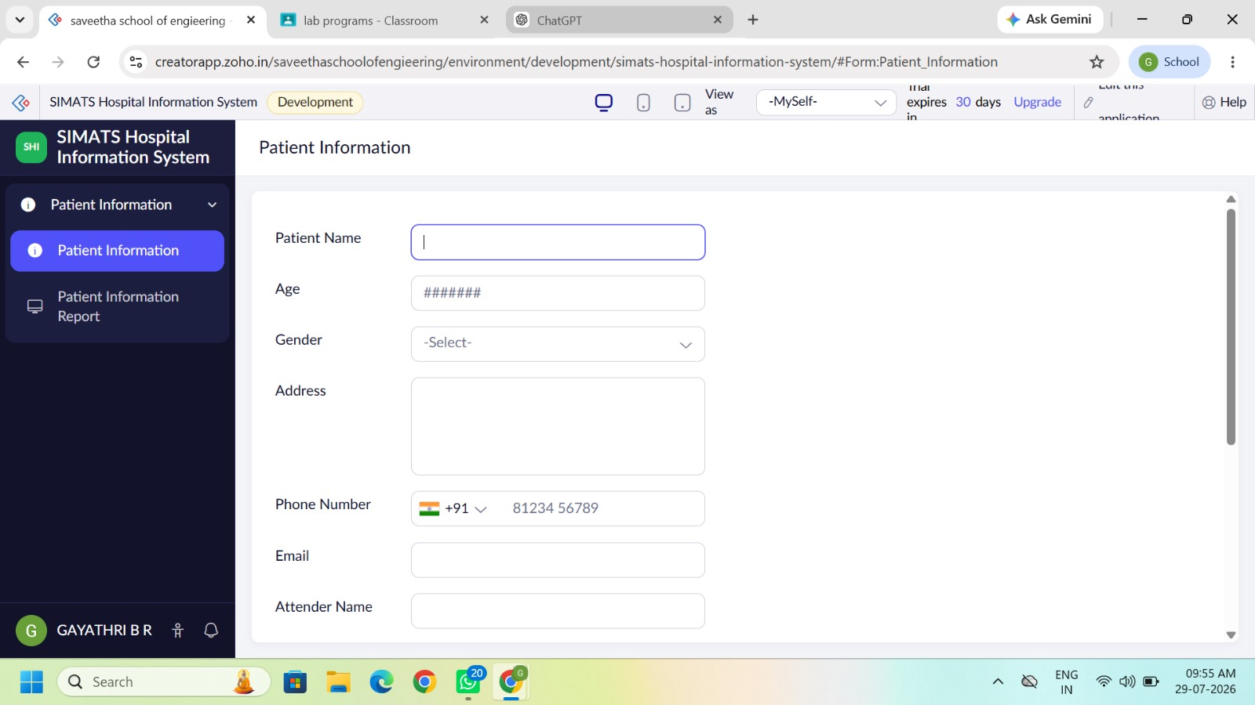
WORKFLOW:

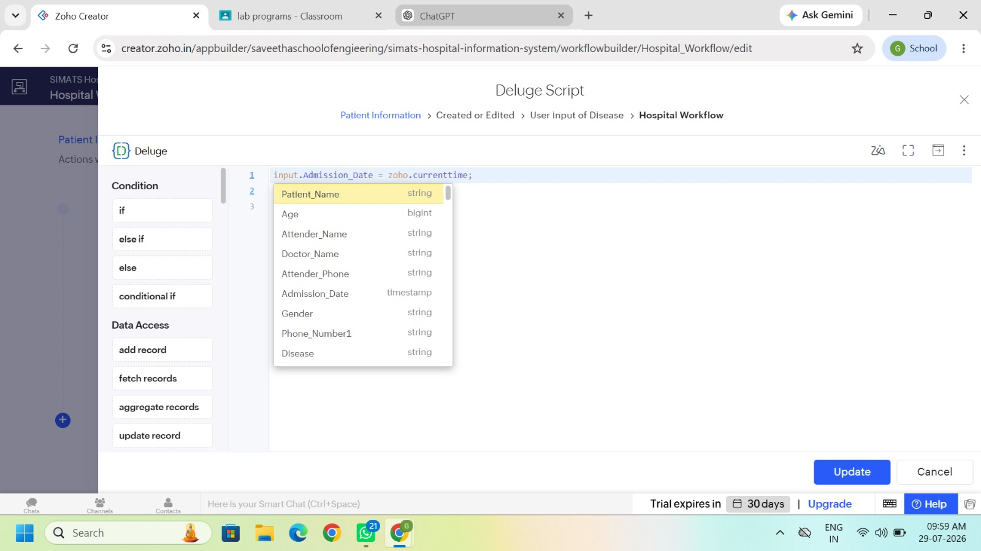
RESULT:
A cloud-based Hospital Information System was successfully developed using Zoho Creator. The application stores patient, attender, doctor, and treatment details, automatically records the registration date, updates the patient status, and demonstrates the Software as a Service (SaaS) model using a cloud platform.

